Book Talks
You’ve been reading great books, and now it’s time to share some of them with your fellow students! We’ll be doing this by giving book talks.
Due March 19th

What is the purpose of a book talk?

Think of a book talk as a commercial for a book. Your job is to persuade someone to read the book you are talking about. You’ll know you gave a great book talk if someone else in the class decides to read your book.

What are the elements of a book talk?

Your book talk will have four parts:

- Hook
- Information about the book
- Analysis of the book
- “Selling” Points

How do I get started?

- Choose the book you want to talk about. READ IT!!! Pick a book that you love. Remember, your goal is to persuade your audience to read the book. If you don’t like the book, you won’t be able to convince your audience that it’s wonderful!

- Memorize your talk. You may use note cards, but do NOT plan on reading off of the cards. The cards are just to help you remember your main points.

- Practice! Practice! Practice!

What happens on the day I give my talk?

- Bring the book with you. Do not ask to go to the library to see if it is available. Be prepared and bring the book with you!

- Give your talk. You should not talk for more than five minutes.

- Be ready to answer questions about the book.

How can I do well?

- Read the book. If you read the book a month or weeks ago, familiarize yourself with the book again.

- Memorize your talk and practice it.

- Keep it fresh. Think of new ways to introduce your talk and keep your audience interested. You talk shouldn’t sound like anyone else’s.

- Use your own words! If you copy the book jacket, flap, or another summary of the book, you are plagiarizing.

- Use specific examples and details from the book. Saying, “This is great!” can be applied to any book. What makes this book a fabulous read?

- Use the rubric.

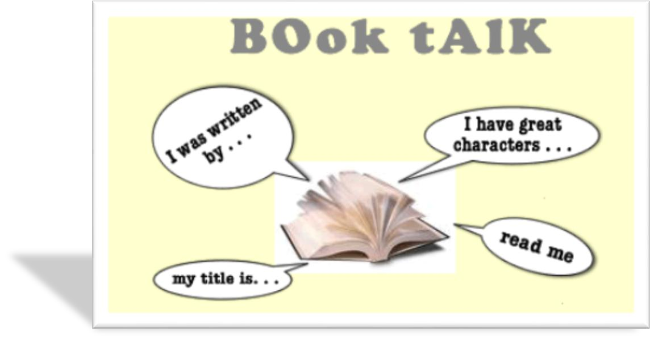

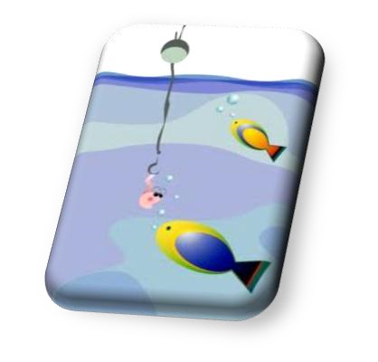
Hooks

Introduce your talk by using a “hook” that will interest your audience.

- Ask a question
- Describe the setting
- Read an exciting passage
- Describe a problem in the book
- Use a surprising statement
- Explain the main idea behind the story
- Explain the problem the protagonist has 8. Tell a riddle that relates to the book

Questions to Use When Analyzing Your Book

After you’ve introduced your book and told your audience something about it, use two of these questions below to delve deeper into the book.

Choose questions that apply to the novel you’ve read and that show you’ve thought about the meaning of the book. Be sure to refer to concrete details from the book to support your thoughts. Check off the questions as you use them.

- What makes this book unique?
- What challenges did you have when reading this?
- What makes the main character interesting?
- What is the primary conflict in the book, and why is it important?
- What is the theme of the book? How do you know?
- Why is this an important book for kids to read?
- Who is the protagonist and what qualities does he or she have?
- Who is the antagonist and what qualities does he or she have?
- Why is the setting important to the story?
- How does the protagonist change in the novel?
- What is your favorite scene in the book and why?
- Is this a believable story? Why or why not? Does the believability affect how you feel about the book?
- What is something about the story that surprised you?
- What lingering questions and thoughts does the book leave with you?
- What ideas from the book will stick with the reader once he or she is finished with it?
- Did you believe the characters were realistic? Why or why not? How does that influence the story?
- What choices does the character make that adds to the excitement or interest to the story?
- What positive and negative qualities of the protagonist make the character believable?
- What were some of the subplots of the novel that make the overall story enjoyable?

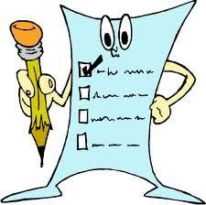

Book Talk Survey

Name ____________________________________________

Book Talk Date __________________ Today’s date _________________________

Title of the book:
Author:
Genre:
Publisher:
Copyright Date:
Number of Pages:
Answer the following questions on loose leaf, MLA Format. Be sure to answer in complete sentences.

Hook: What is the hook you’re using?

Summary: Please write a complete summary of the book. Include information about the beginning, middle, and end of the book. Please include spoilers here!! (Just no spoilers in your talk!)

How will you persuade your audience?

What’s so great about this book?

What is your favorite part of this book?

Who would like this book (don’t say “everyone”)?

What is the approximate grade level of the book?

What analysis questions will you be addressing in your talk?

Book Talk Rubric

Book _______________________________________________________

Name & Time __________________________________________________
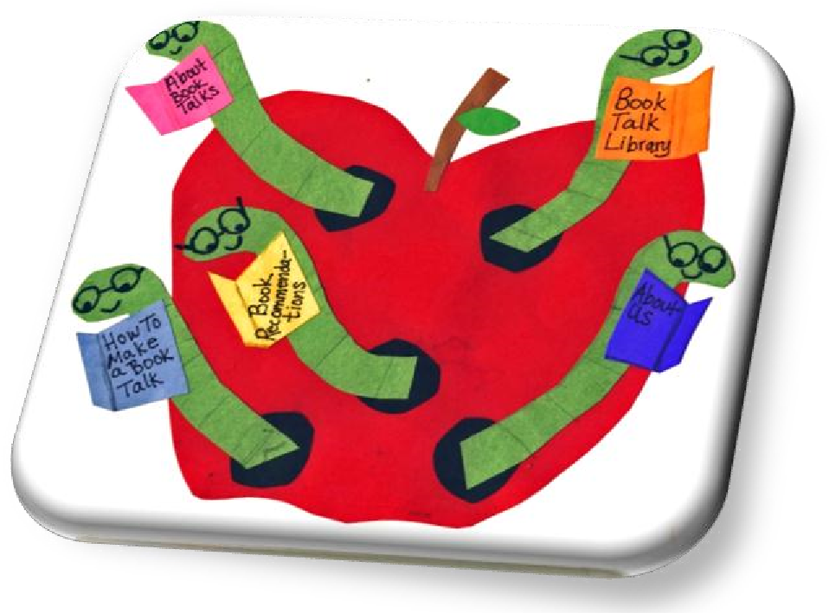
10 | Prepared. You brought the book in on the day of the talk.
5 | Interesting. You used a hook and connected it to your talk.
10 | Summary. You summarized the book giving the audience information about the book including genre, setting, plot, characters, and theme. You blended this information together and didn’t list it.
10 | Thoughtful. You addressed two of the analysis questions about the book, but did not just list the questions. You incorporated this into your talk.
10 | Persuasive. You did a good job “selling” the book. You made it clear what the best part of the book was. You were specific in your discussion.
5 | Conclusion. You ended the talk in a thoughtful way. You didn’t just stop.
10 | Voice. You were loud and clear. You used expression.
10 | Eye Contact. You looked at everyone in the group.
10 | Posture/Body language. You stood up straight and looked relaxed.
10 | You memorized your talk. You used your notes or presentation only to keep you on track.  Total: /100

