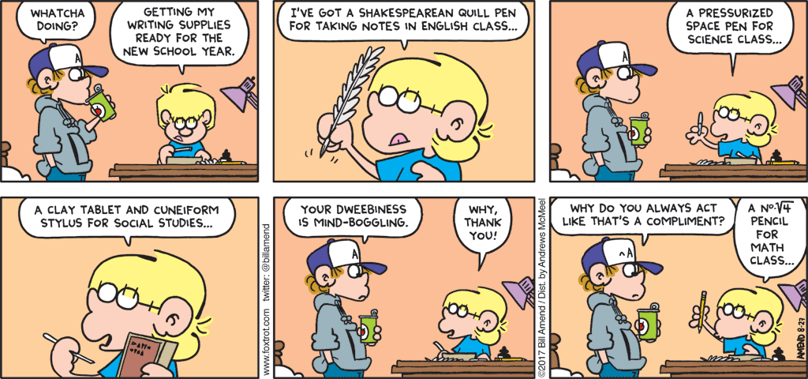
What is happening in the first three frames?
What happens in the last three frames?
In a culture where we are bombarded with other people trying to define us, how do we create our own identities?
Do these identities carry into adulthood?
Does life seem fair for this student? What makes a good life?

